**Practical No:-8**

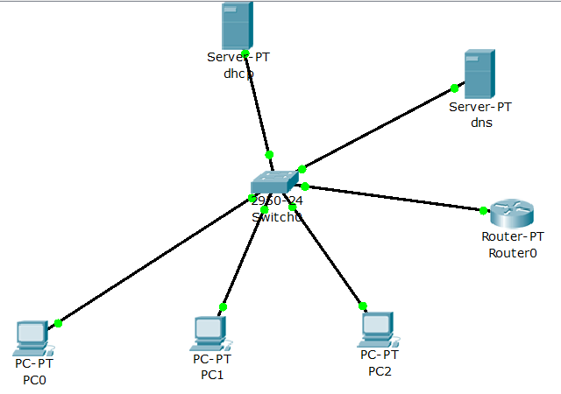

**Step 1:-Configuring Router0**

Router>en

Router#config t

Enter configuration commands, one per line. End with CNTL/Z.

Router(config)#hostname r1

r1(config)#interface f0/3

%Invalid interface type and number

r1(config)#interface f0/0

r1(config-if)#ip address 192.168.1.1 255.255.255.0

r1(config-if)#no shut

%LINK-5-CHANGED: Interface FastEthernet0/0, changed state to up

%LINEPROTO-5-UPDOWN: Line protocol on Interface FastEthernet0/0, changed state to up

r1(config-if)#exit

**Step 2:-IP Configuring of server 0 i.e dhcp**

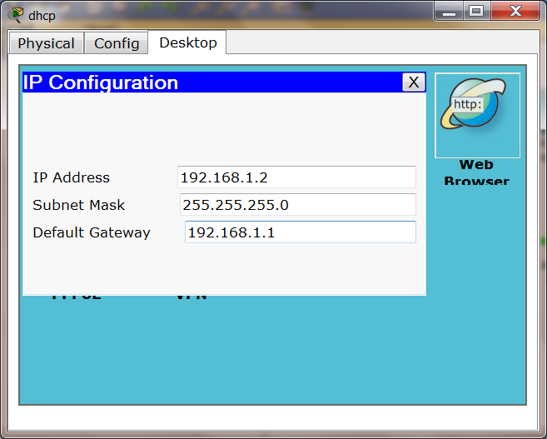

**Step3:-Configuring DHCP**

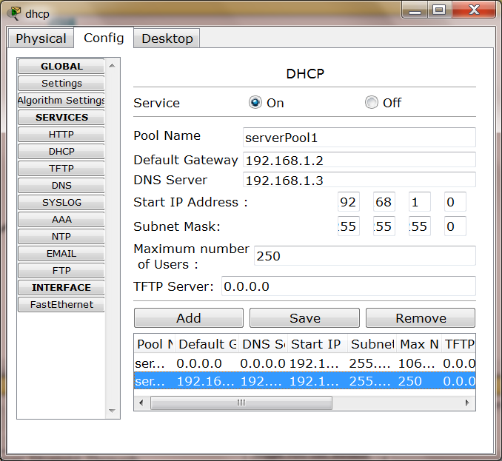

**Step 4:- IP Configuring of server 1 i.e dns**

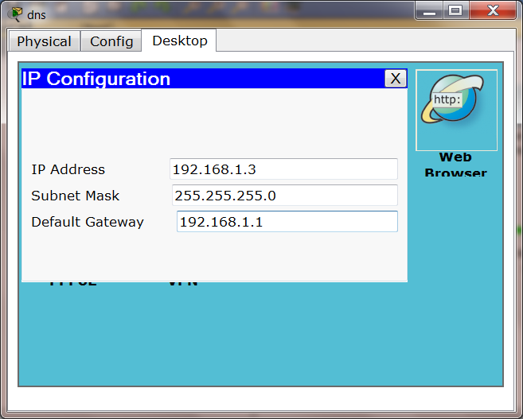

**Step 5:-Configuring PC0**

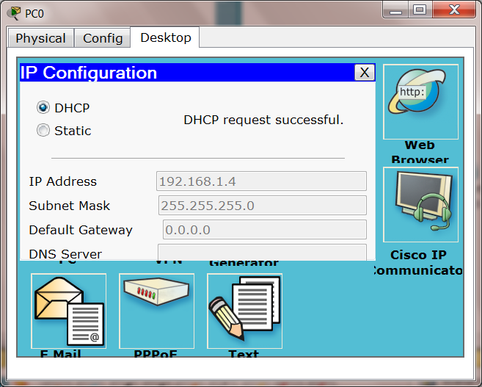

**Step 6:-Configuring PC1**

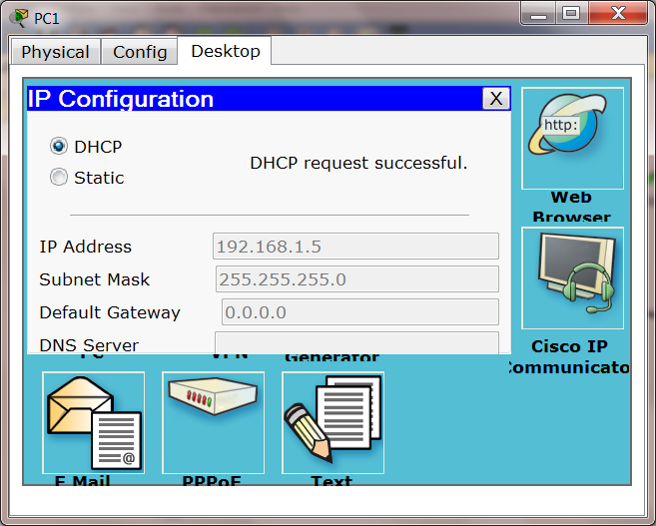

**Step 7:-Configuring PC2**

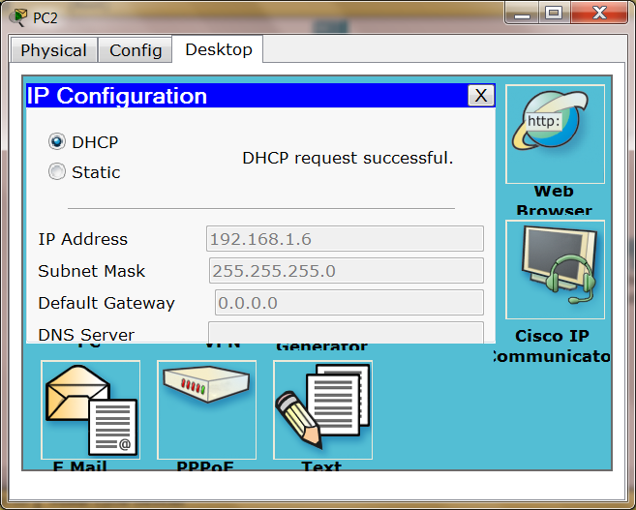

**Step 8:-Go to PC0>desktop>command prompt**



**Step 9:-Go to PC0>desktop>web browser**

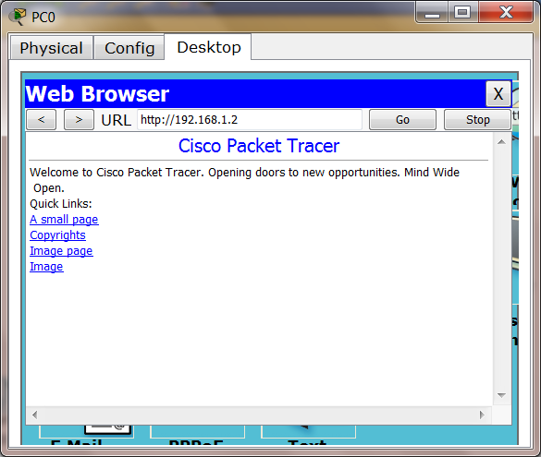

**Step 10:-Configuring DNS**

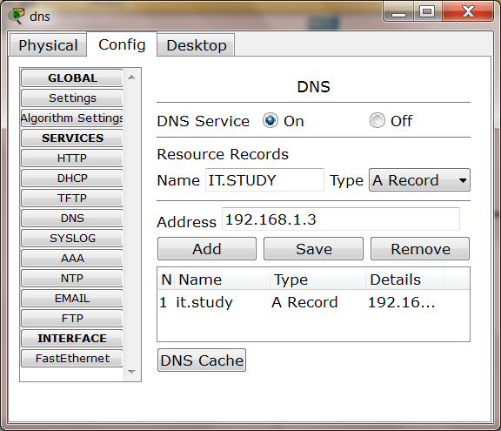

**Step 11:-Go to PC0>desktop>web browser**

